
CITY OF MACOMB
FREEDOM OF INFORMATION ACT INFORMATION

Summary of the City of Macomb:
The City of Macomb is located in west central Illinois. We are the home to Western Illinois University and serve as the county seat for McDonough County. Macomb offers strong manufacturing opportunities, along with a progressive medical community, a broad and varied retail sector, and an abundance of cultural events and talent. Macomb’s blend of agriculture, industry, service, retail, education, and culture, along with our diverse community, makes us the regional center of the area.

Total Operating Budget for FY26-27: $58,119,009.00

Location of Offices:
City Hall  232 E. Jackson St.  Macomb, IL 61455  (309) 833-2575 | Macomb Fire Department  219 W. Jackson St.  Macomb, IL 61455  (309) 836-7800 | Macomb Police Department  120 S. McArthur St.  Macomb, IL 61455  (309) 833-4505 | McDonough County Public Transportation  701 E. Pierce St.  Macomb, IL 61455  (309) 837-7433
Public Works Department  233 Center St.  Macomb, IL 61455  (309) 833-2821 | Oakwood Cemetery  N. Randolph St.  Macomb, IL 61455  (309) 833-5100 | Wastewater Treatment Plant  901 W. Grant St.  Macomb, IL 61455  (309) 833-2088 | Water Treatment Plant  1412 N. Randolph St.  Macomb, IL 61455  (309) 836-3916

Approximate Number of Employees: 167 (includes full time, part time and seasonal)

City Council/Elected Officials:
Mayor: Michael J. Inman City Clerk: Renee Lotz Treasurer: Andrea Henderson
First Ward Alderperson: Justin Schuch Fifth Ward Alderperson: Ashley Katz
Second Ward Alderperson: John Vigezzi Alderperson at Large: Jennie Hemingway
Third Ward Alderperson: Byron Shabazz Alderperson at Large: Don Wynn
Fourth Ward Alderperson Dave Dorsett

Boards and Commissions:
Equal Opportunity and  Fair Housing Commission  Larry Adams  Julia Albarracin  Belinda Carr  Kali Foxall  Brandon Nelson  Lorette Oden  Doug Rossio  2 Vacant Seats | Zoning Board  of Appeals  Tina Belz  Kate Cobb  Carl Ervin  Ron Runser  Suzan Nash  Nathan Wallen  1 Vacant Seat | Historic Preservation  Commission  Jan Armstrong  Savannah Ballard  Dennis Danowski  Lara Dively  Ashley Katz  Sue Scott  Lin Stults | Planning Commission  John Bannon  James Buwick  Gayle Carper  Christine Farr  Laura Leezer  Jim Miner  Chad Sperry  Sam Thompson  Jeanetta Thorpe  Craig Young  1 Vacant Seat | Tree Board  Ross Braun  Dan Glenn  Tim Howe  Margaret Ovitt  Brenda Sayre  Barrie McVey  Fire & Police Commission  Beau Ingledue  Jill Myers  Ron Pettigrew  Liquor Advisory Commission  Marshall Ervin  Jennie Hemmingway  Steve Horrell  Wendell Seals
Freedom of Information Act Requests:
FOIA requests may be submitted in person, via email, and via fax as set forth below.
FOIA Officers: Lisa Scalf, City Attorney Fax: (309) 836-5070
Renee Lotz, City Clerk Email: foia@cityofmacomb.com
232 E. Jackson St.
Macomb, IL 61455
(309) 833-4373
Fees may be assessed as permitted within the Freedom of Information Act as follows:
- The actual cost of the recording medium (i.e. flash drive)
- No charge for the first 50 printed pages. Each page thereafter shall be $0.15 per page.
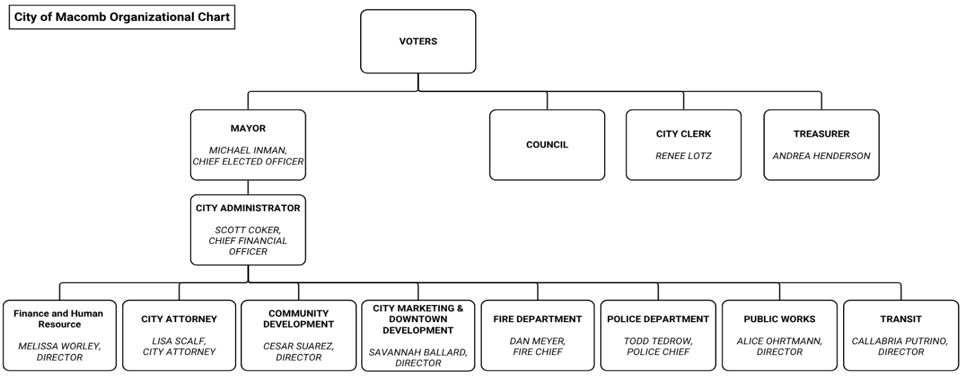
- Commercial Requests: $10.00 per hour for each hour spent searching for and retrieving a requested record or for examining the record for necessary redactions.

